|  |  |
| --- | --- |
|  | **USER MANUAL**  **COBIT19 CONSULTANTS** |

Table of Contents

Introduction 1

Application Background 1

Application Purpose 1

System Capabilities of the Software 1

User Roles 3

Use of the COBIT Consultants COBIT19 Software 4

Accessing the software 4

Login to the software (Admin, Head-Auditor, Auditor, Client) 4

Register New User 6

How to see the audits assigned to a user 7

How to manage audits (For admins and head auditors) 8

Audit dashboard 9

Goals cascade (Only Available to Head Auditor and Administrator) 10

Design Factor Report (Score) (Only Available to Head-Auditor and Administrator) 11

Example of Canvas report that can be downloaded: 12

Scope Selection (Only Available to Head Auditor and Administrator) 13

Add Members (Only Available to Head-Auditor and Administrator) 14

View and Complete Audits (Available to Head-Auditor, Auditors, and Administrator) 14

Knowledge Areas 16

Assessment guides 18

Suggested Process to follow when using COBIT Consultants COBIT19 Software 19

Possible challenges and errors and how to potentially solve them. 20

Conclusion 21

# Introduction

We appreciate your selection of COBIT Consultants' COBIT19 software. This software was created to enhance the efficiency and security of COBIT19 audits. It is aligned with the COBIT19 framework developed by ISACA, with provisions for adapting to any future framework updates.

## Application Background

Previously, our client relied on an Excel Spreadsheet to apply the COBIT19 framework to their organization. However, this method had several limitations, including security issues, inadequate backup capabilities, and complexity for auditors unfamiliar with Excel. These challenges prompted the development of the COBIT Consultants COBIT19 software, with a commitment to addressing these issues.

## Application Purpose

The primary objective of our COBIT19 software is to guide auditors through the COBIT19 framework implementation process. We achieve this by offering comprehensive documentation, creating a seamless flow through the framework's steps via user-friendly pages. Our software is designed to accommodate both novice and experienced auditors, and it maintains a familiar interface for those transitioning from Excel, minimizing training requirements for implementation.

## System Capabilities of the Software

The system showcased in this user manual includes the following capabilities available to users:

* The system is hosted as an online web application using the NWU servers as hosting services. This allows multiple users to interact with the system at the same time. The software is also a web server application, which means that the performance of the software is not dependent on the resources made available by the client’s device.
* The software's data is stored in a Microsoft SQL database hosted online using NWU servers as hosting services. This allows for more secure storage of data and reduces the need for physical security.
* The software makes use of security features, such as a login page and password hashing. This allows for more controlled access to the software and the data stored and used by the software.
* The software makes use of predefined templates and pages like the Excel Spreadsheet employed by the client. These pages include user-friendly functions such as automatically updating graphs that allow the user to receive feedback immediately on their input. These pages also have a natural flow enforced by the software itself to minimise the possibility of confusing the client.
* The software automatically stores the input as the user provides their input which serves as a failsafe should an interruption occur while using the software. This prevents the loss of work and allows the auditor to resume where they left off.
* The software will also allow the users to view their input in summarized and detailed reports. These reports can be sent via electronic measures such as email and can also be printed.

These capabilities and their uses will be explained in the following sections of the user manual.

## User Roles

1. **Administrator User:**

The administrator user will have all the privileges that can be assigned to a client user. The administrator user will be able to:

• Add new client users to the database.

• Will be able to promote or demote client users. (For example, Auditor -> Head-Auditor).

• Will be able to delete client users from the database.

• Will be able to create new audits.

• Will be able to assign auditors to new audits.

• Participate in completing audits.

• Will be able to generate reports and send them.

• Can edit audits that are not yet finalised.

2. **Head-Auditor:**

The Head-Auditor user will be able to start and manage audits but will not be able to delete users. The Head-Auditor will be able to:

• Will be able to create new audits.

• Participate in completing audits.

• Will be able to assign auditors to new audits.

• Will be able to generate reports and send them.

• Can edit audits that are not yet finalised.

3. **Auditor:**

The Auditor users will be divided into 2 types: Governance auditors who only handles the EDM knowledge areas and audits assigned to them and management auditors who handles all the rest of the knowledge areas and audits assigned to them. The Auditor user will be able to participate in completing audits.

4. **Client:**

The Client is the recipient of the report generated by the Administrator user and Head-Auditor user. The Client will be able to view reports generated from the results of the audit.

# Use of the COBIT Consultants COBIT19 Software

## Accessing the software

The software is entirely web-based, meaning that no installation of the software or additional software is necessary.

To access the COBIT Consultants COBIT19 Software, any recently updated web browser can be used to access the software.

To access the software, you have to be connected to the NWU’s intranet. Please enter the following link into the address bar of any modern web browser: (Enter web-link here for your access)

Note: The link can change if the COBIT Consultants COBIT19 Software is hosted somewhere else. Please check with your administrator for the correct link to the software.

## Login to the software (Admin, Head-Auditor, Auditor, Client)

Once the client has entered the link into the address bar of their web browser, the software will take the user to the login page.

Figure 1: Login screen

The above page will be the first pages a client will encounter when they access the software via the link provided above.

1. The first page a user will be the login page seen above. The client can enter their email address which will be used to uniquely identify each user in the data. The software will use validity checks to ensure that the email entered is according to the correct email format in the field. An example of a correct email: [*user@entry.co.za*](mailto:user@entry.co.za).
2. The user can enter the password for their account. The password also employs the use of validity checks to ensure that strong passwords are used for software profiles. A strong password is between 8-16 characters. The password should contain at least 1 special character (for example @, #, %), 1 numerical character (for example 1, 5, 9), 1 uppercase character, and 1 lowercase character. The user can enter their password in the field.
3. For convenience, the user can choose their web browser to remember their account details. This is very insecure and is only recommended on devices where the client is the sole user of the device. The user can check the box to enable this feature. If left unchecked, the client will have to input their login details every time they want to access the software.
4. When the user has entered their details, the software will check if the user exists, and if the user exists, the software will check if the password they entered is correct for the user profile identified by the email address entered in the field. If all the details are correct, the user will be provided with the correct authority to access the software. If the details they entered are incorrect, the user will be notified, and they will be denied access to the software. The user can attempt a login with their details by clicking on the login button.
5. When the login was successful the users will be greeted by the following screens.
6. Only admin users or head-auditors can create new accounts for users by clicking on the “Manage Users” button in the navigation pane on the left.
7. The “Assessment Guides” button will provide the user with PDF documents explaining the COBIT19 audit processes.

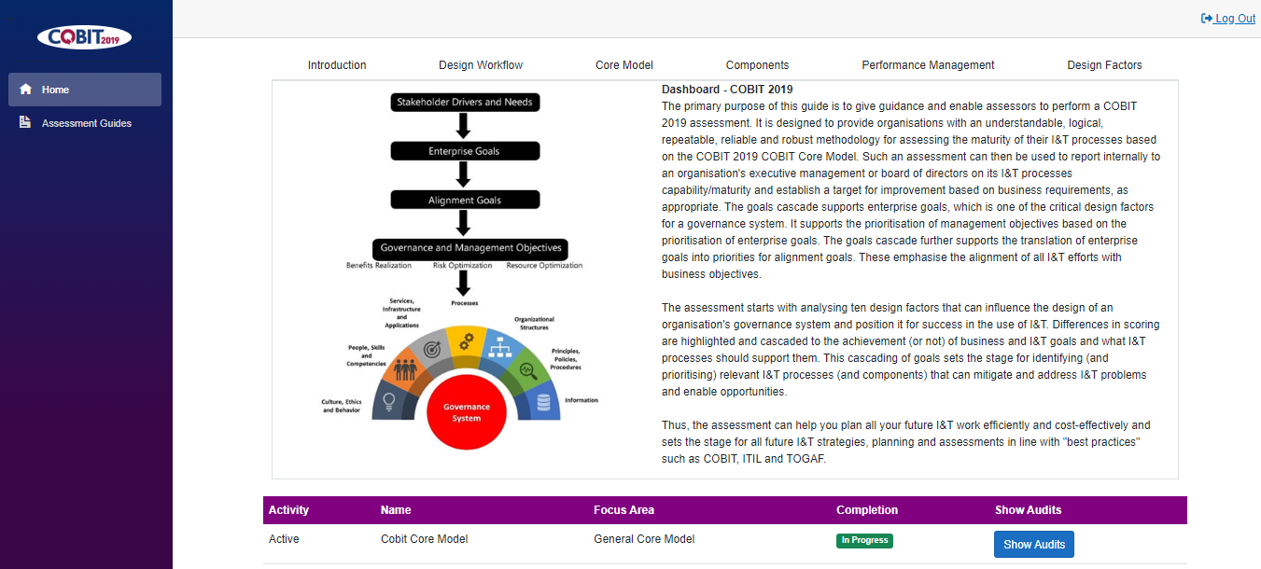

Figure 2: Home page for auditors

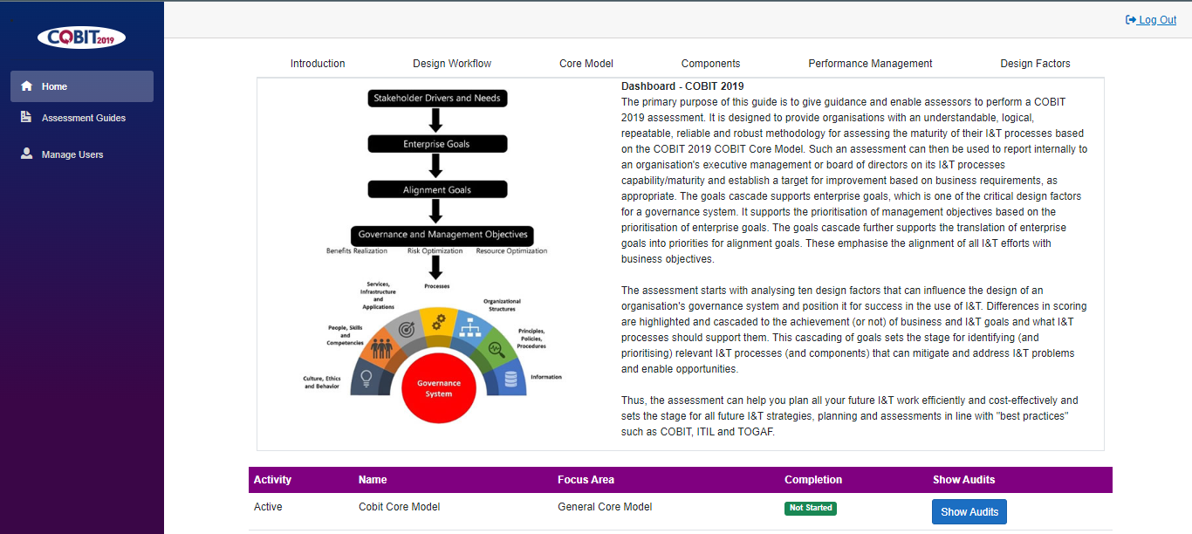

Figure 3: Home page for admin or head-auditor

## Register New User

Figure 4: Manage users screen for admin or head-auditors.

The steps below will detail the process to register a new user.

1. To access the manage users page to add or delete users, press the “Manage User” button in figure 4.
2. To login to the system upon first use, please enter the first name of the user in the “First Name” field. .
3. Please enter the last name of the user in the “Last Name” field.
4. Enter an email like “[Admin@COBIT19.com](mailto:Admin@COBIT19.com)” in the Email field. When a new user is added to the system, this page will still capture their details, but the Administrator or head-auditor must still assign them a role.
5. Please enter a valid password for the account. The password must satisfy the following:
   1. Password length must be between 6 – 18 characters long.
   2. Must contain at least 1 special character (For example @, #, $).
   3. Must contain at least numerical characters (1, 5, 9).
   4. Must contain at least 1 upper case character.
   5. Must contain at least 1 lowercase character.
6. Users can be deleted by selecting them form the dropdown box and pressing the delete button.

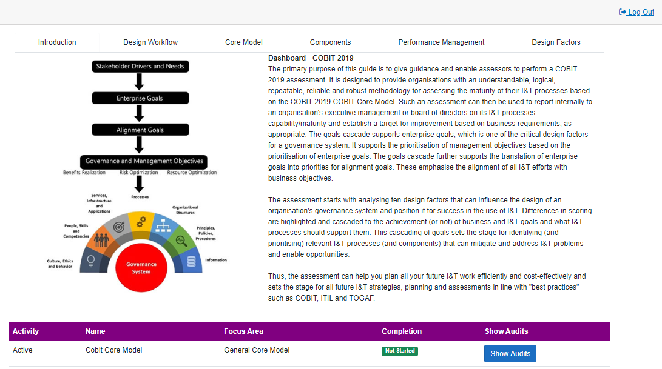

## How to see the audits assigned to a user

1. Users can log out by pressing the log out link in the top right corner of the home page.
2. Users can see the audits assigned to them by pressing the Show Audits button on the home page which will lead them to the following page listing all the audits assigned to them.

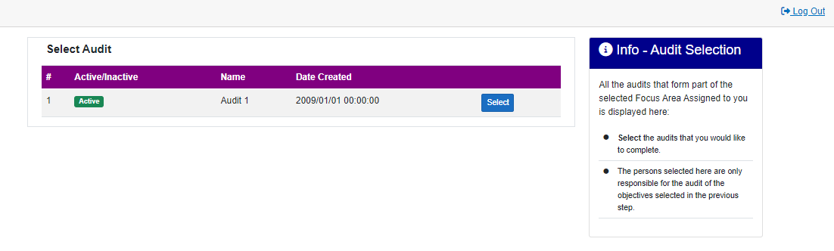

Figure 5: Select audit page for auditors.

Figure 6: Select audit page for admin or head auditor.

## How to manage audits (For admins and head auditors)

Figure 7: Manage audits page.

1. The Manage Audit page can be accessed by pressing the “Manage Audits” button in the top right corner in Figure 6.
2. The administrator or head auditor can create new audits by assigning it a name and pressing the “Create New Audit” button.
3. The administrator or head auditor can assign users to an audit by selecting the audit and the users from the drop-down boxes and pressing the “Add User” button,
4. The administrator or head auditor can delete an audit by selecting the audit from the dropdown box and pressing the “Delete Audit” button.

## Audit dashboard

The following pages will be displayed for each audit on the “Select Audit” page

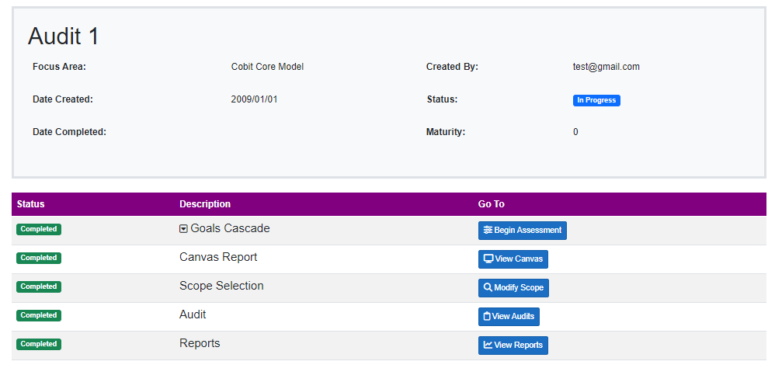

Figure 8: Audit dashboard for auditors

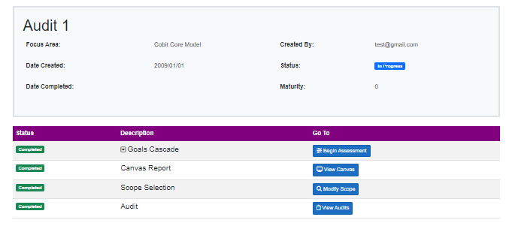

Figure 9: Audit dashboard for admin and head auditor

1. The top panel gives an overview of the current audit.
2. The following button’s functions:
   1. Begin Assessment: Begin the goals cascade assessment (Only Available to Head Auditor and Administrator).
   2. View Canvas: Displays a summary vie of all the design factors(Only Available to Head Auditor and Administrator) .
   3. Modify Scope: Allows user to choose only the knowledge areas that the business considers the most important (Only Available to Head Auditor and Administrator).
   4. View Audits: Begins the Audit/Maturity assessment process.
   5. View reports: Provides the user view reports that can be generated and downloaded.

## Goals cascade (Only Available to Head Auditor and Administrator)

The design factors will be used to determine what areas of their Information and Communication Technology and Information Technology Governance are important.

1. Selecting the scores from each of the rows will change the row's value corresponding to the column. For example, choosing the value column 3 for the Growth/Acquisition row will assign an importance value of 3 for Growth/Acquisition.
2. If the client has finished inputting their importance values for each of the rows, they can click on the “next” button or one of the numbers in the navigation bar underneath the graph. This button will take them to the following design factor in accordance with the predefined flow of the software.
3. The graph displays all the knowledge areas and the effect that each of the design factors will have on each of the knowledge areas. As the user changes their selection of important values, the graph automatically updates to reflect the changes.
4. The above graph shows an example of the feedback a user may receive when inputting their values.
5. The right panel displays extra information that explains the current design factor.

## Design Factor Report (Score) (Only Available to Head-Auditor and Administrator)

The final summary considers all the design factors and the functionality is as follows and can be accessed by pressing the “View Canvas” button in figure 9.

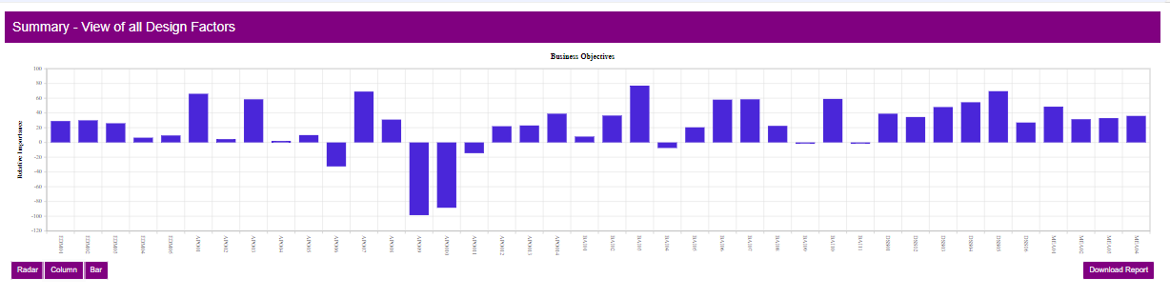

Figure 10: Column Chart Summary - View of all Design Factors

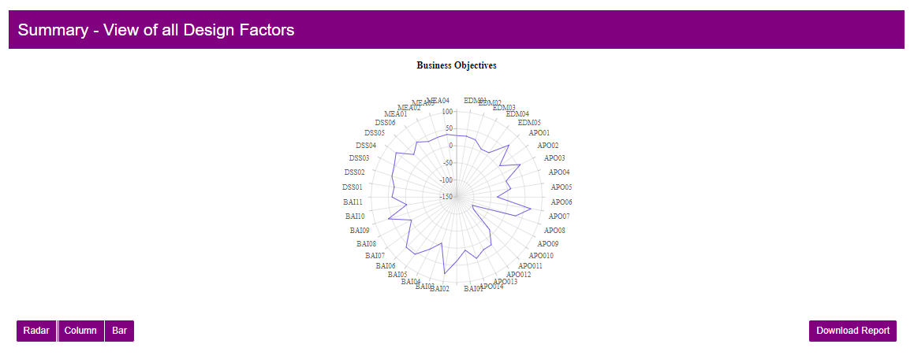

Figure 11: Radial Chart Summary - View of all Design Factors

1. The graphs can be changed to be in Bar, Radial or Column format by pressing the buttons for each underneath the graph.
2. The graph can be downloaded by pressing the Download Report button.

## Example of Canvas report that can be downloaded:

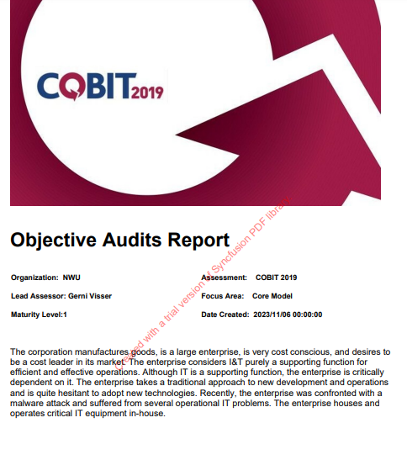

Figure 12: Example Canvas Report

## Scope Selection (Only Available to Head Auditor and Administrator)

The scope selection involves choosing only the knowledge areas that the business considers the most important.

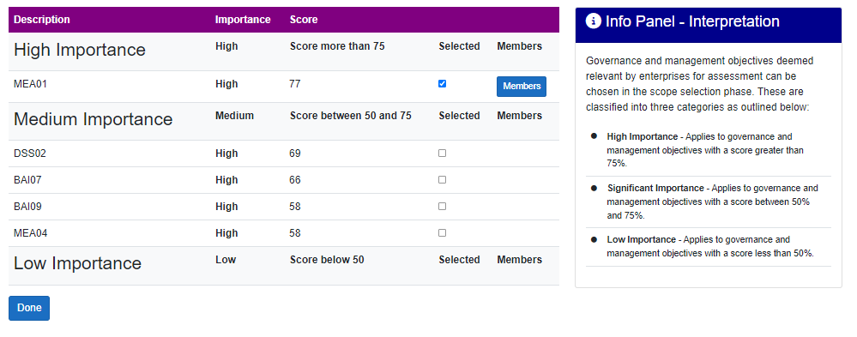

Figure 13: Scope selection page

1. The “Done” button can be used to proceed with the audit process.
2. When a knowledge area has been selected by checking the checkbox in the Selected column it will available to audit.
3. The most important knowledge areas appear in the high-importance area. Only knowledge areas with a score above 75 are located here.
4. The significantly important knowledge areas appear in the significant importance area. Only knowledge areas with a score between 75 and 50 are displayed here.
5. The low-importance knowledge areas appear in the low-importance area. Only knowledge areas with a score of lower than 50 are displayed here.
6. The auditors can be assigned to each knowledge area by pressing the “Members” button in the Members column. This will forward the user to the following page where members can be added by checking the checkbox in the Selected column.

Figure 14: Assign members page

## Add Members (Only Available to Head-Auditor and Administrator)

1. The Head-Auditor and Administrator can only add members to a knowledge area by checking the selected check box if the users were added to the specific audit in the manage audits section.

## View and Complete Audits (Available to Head-Auditor, Auditors, and Administrator)

The knowledge areas are then assigned to the auditors and can be viewed on the “Maturity Assessment” Page below by pressing the “View Audits” button on figure 9.

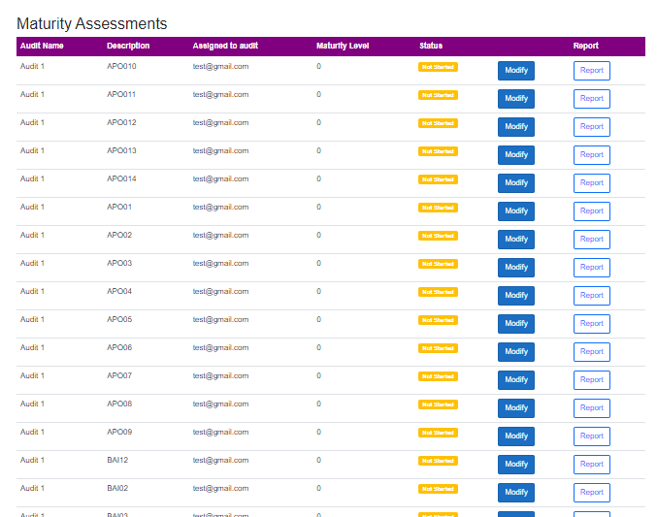

Figure 15: Maturity assessments page

1. The name of the Audit to which the knowledge area belongs is displayed under the “Audit Name” column.
2. The name of the knowledge area is displayed under the “Description” column.
3. The auditors that were assigned to each audit is displayed in the “Assigned to” column.
4. The status of the knowledge area is displayed under the “Status” column. This status of each of the knowledge areas can be displayed as:
   1. Not Started = The knowledge area has not yet been started.
   2. In Progress = The knowledge area has been started but not yet completed.
   3. Completed = The knowledge area has been fully completed.
5. The maturity level of the knowledge area will be displayed in the “Maturity level” column.
6. To navigate to the knowledge area, the user can click on the “Modify” button. This will direct the user to the knowledge area where they can then complete the knowledge area audit.
7. To generate and download an individual knowledge area report press the Report button (See example report underneath).



Figure 16: Example individual report for APO10 knowledge area.

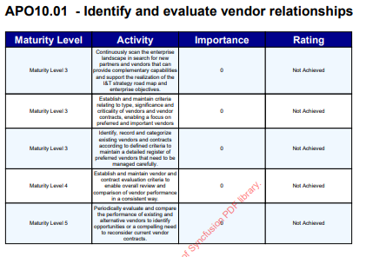

Figure 17: Example individual report continued.

## Knowledge Areas

To complete the knowledge area audits, the user will see that the pages are divided into components for each of the knowledge areas. All the knowledge areas follow a similar flow and BAI02 will be used in this example.

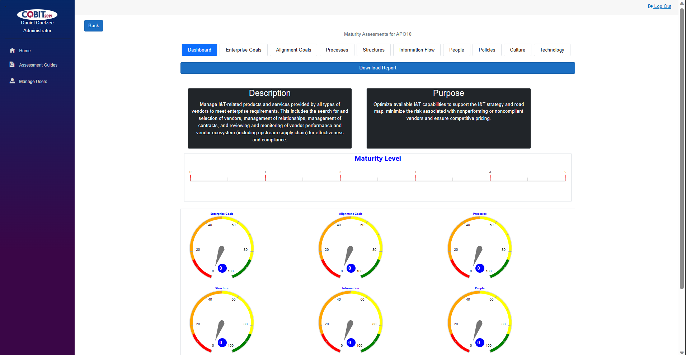

1

Figure 18: Audit dashboard page

1. In the tab, denoted by 1, all the different components of BAI02 are displayed and can be freely navigated to and from. Currently, the Dashboard is selected and displayed.
2. The dashboard displays gauges to inform the user of each component’s score.
3. If the Enterprise Goals button is pressed it will forward the user to the following page.
4. A maturity assessment report can be generated by clicking the “Download Report” button on the Dashboard page.

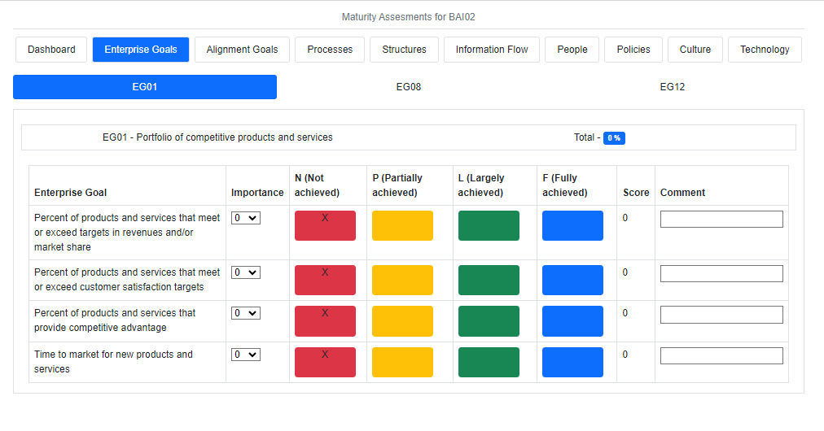

2

Figure 19: Example of the Enterprise Goals component of the knowledge area

1. Currently, the Enterprise goals component of BAI02 is selected and displayed.
2. Certain components of a knowledge area will also contain sub-questions. These sub-questions can be found in the sub-question tab, denoted by 2. These sub-questions can also be freely navigated to and from. Currently, EG01 is selected and displayed.
3. The description of the score will be provided for all the knowledge areas in the 1st field.
4. In the knowledge areas, the importance can be rated from 1 to 10 in the dropdowns, the scores will also automatically update in the Achievement by marking the column with an “X” and updating the score total to the left of the achievement columns.
5. The score will automatically be displayed in the “Score” column,
6. The total maturity score will be automatically displayed it in the Total row next (right) to the subcomponent name.
7. The “Comment” column allows the user to add custom comments to the related guidance rows.
8. Note: All input is automatically saved, meaning that should the connection to the internet be lost, the last data that was input by the user is automatically saved to the database.
9. When the user clicks on the “DashBoard” button the user will be directed to the dashboard for the knowledge area that they are currently busy with, namely, BAI02 in this case.

## Assessment guides

The assessment guides can be found under the “Assessment Guide” tab in the navigation page on the left of the screen.

These guides will help auditors with the audit processes.

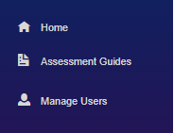

Figure 20: Assessment guide page

# Suggested Process to follow when using COBIT Consultants COBIT19 Software

This section will aim to provide some general use tips for using the software. This process will aim to guide you through the process of deploying the COBIT19 software effectively and help you make the most of the helpful features implemented in the software.

**Step 1: Log In**

This step involves logging into the system to be able to access the software itself. Please do remember the user email and password you used when you created your own profile that is stored in the system. If you have forgotten your email and password, please contact your system administrator appointed by your organisation to reset your email or password.

**Step 2: Create a new audit or select a previous audit to finish**

Once you have logged in, you will be able to select any of the audits you have previously created or participated in, which will allow you to make edits in accordance with your authorisation within the system itself. Or alternatively, you can create an entirely new audit. By creating a new audit, you will be able to name the new audit and create it on the Manage Audit page. Once the new audit is created, it will be selected, and you will see the progress of that selected audit. From the page, you can start from the beginning with an audit by starting with the design factors.

**Step 3: Complete Design Factors and Select Scope**

Start with the design factors. The design factors are used to determine the areas of importance within the business and will also determine which knowledge areas will be the most important to audit. When the design factors are completed, the auditor will be given the opportunity to select the knowledge areas to be audited. The most important knowledge areas will already be selected with the option to select less important knowledge areas if they are deemed necessary by the business.

**Step 4: Assign Auditors to knowledge areas**

When the scope has been selected, the Head-Auditor will be able to assign Auditors to each of the selected knowledge areas. This is to spread the workload among auditors and means that audits can be completed much earlier. By default, the Head-Auditor will be selected as the default Auditor for all selected knowledge areas. Please ensure that work is shared evenly between Auditors.

**Step 5: Complete the knowledge areas**

When the Auditors have been assigned to their respective knowledge areas, they will have access to them and can immediately start with them. The Auditors can then work their way through knowledge areas, following the flow determined by the software or they can also freely switch between components and sub-questions of the knowledge area they are busy with. The data is automatically saved so they leave the audit and resume at a later stage. When the auditor has completed their audit, they can finalise them where the data is locked in the database and can no longer be edited. The software also keeps track of the knowledge area’s progress, helping the auditors keep track of their progress.

**Step 6: Reporting**

The user can then generate reports on the specific knowledge areas or the canvas as whole. These reports can then be downloaded to the user’s device in PDF format. These reports can then be sent via email or other means.

# Possible challenges and errors and how to potentially solve them.

**1. Error:** The Email field is required

**Potential solution:**

This error message will be shown when no email address has been entered in the email field on the Log In page. Enter a valid email address, making sure that your email does not contain any typos to potentially solve this error.

**2.** **Error:** The Password field is required

**Potential solution:**

This error message will be shown when no password has been entered in the password field on the Log In page. Please enter a valid password. A valid password satisfies the following:

* Contains at least 1 special character (for example @, #, $)
* Contains at least 1 numerical character (for example 1, 5, 6)
* Has a length of between 8 – 16 characters
* Has at least 1 lower case character
* Has at least 1 upper case character

**3.** **Error:** Invalid Email address

**Potential Solution:**

Please enter a valid email address. A valid email address follows the format of a regular email address, for example, [*user@entry.co.za*](mailto:user@entry.co.za)*.*

**4.** **Error:** Invalid Password

**Potential Solution:**

Please enter a valid password. A valid password satisfies the following:

* Contains at least 1 special character (for example @, #, $)
* Contains at least 1 numerical character (for example 1, 5, 6)
* Has a length of between 8 – 16 characters
* Has at least 1 lower case character
* Has at least 1 upper case character

**5.** **Error:** Can not access the software via a web browser

**Potential Solution:**

Please ensure that you are connected to the internet. If you are connected to a network, such as a WIFI network or a cellular network, ensure that you have internet access.

# Conclusion

We at COBIT Consultants hope this new system will provide you with the ability to apply the COBIT19 framework with ease and reliability. The COBIT Consultants COBIT19 software will guide you through the audit process while providing documentation and following a predetermined flow, reducing the possibility of becoming confused.